THE PETROLIA DISCOVERY NEWSLETTER
July 2008 Vol. 3
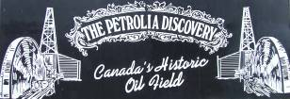
When this newsletter goes to print, spring will have sprung and summer will have officially arrived. Just like the seasons, Petrolia Discovery is springing back to life. The shadows of 2006 are slowly being erased and the sun is shedding new light for Discovery. Discovery has complied with all legislative orders except one which is awaiting action by community individuals. The orders were a financial burden for Discovery and robbed from the general maintenance of the operation. Today, monies are being reinvested in operations and oil shipments are slowly increasing.
Petrolia Discovery AGM 2007
We were delighted with the attendance at the Annual General Meeting. Several suggestions were offered from volunteers and local residents and good ideas were exchanged by everyone. The evening was an opportunity to answer questions and clarify concerns. The auditor presented a positive financial statement and commended the Board for its diligence.
Mr. Ian Blackwood was presented with the honourary life membership in recognition of his many volunteer hours spent at Discovery.

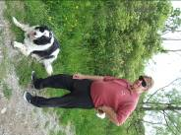

The Board of Directors for 2008 was appointed at the AGM and we will be featuring each member in future newsletters.

Dr. A. M. White, a retired research chemist from Imperial Oil, has accepted the position of Chair for 2008. Dr. White has served Petrolia Discovery for the past four years. His interests are history, traveling, kayaking, photography and geo-caching. Dr. White is very busy at the site doing general site maintenance, acts as a tour guide for special occasions, organizes the annual geo-caching event and helps with other fundraising and events.

Petrolia Discovery applied for and was granted financial assistance for the employment of three tour guides. Summer Career Placements and Summer Job Services are grants provided by the Federal Government and Lambton College.

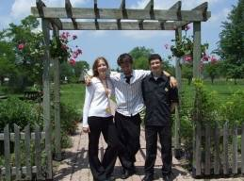
2008 Petrolia Discovery Interpretive Guides
Victoria Rastall – University of Western Ontario
Brendan Hobin – Wilfred Laurier University
Michael Morreale – Queen’s University

Petrolia Discovery wants to thank everyone
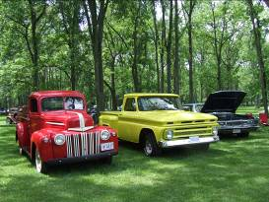
for supporting the Annual Classic Car Show held in
Bridgeview Park. This is one of our most
successful fundraisers and great fun for everyone.
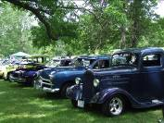

Recently, Petrolia Discovery hosted Wayne State University, Oakland Community College and St. Philips School.
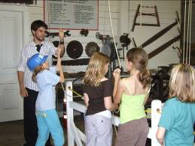
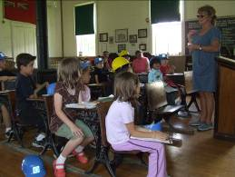

Donors - Mrs. Ruth Brand – vintage heater and various linens
Pat & Gerald Dawson – many garden perennials

Volunteer Cleaners – Alice Goodall & Foster, Valerie Billington, Ruth Brand,
Darlene Joly & Rachael, Carolyn Gould, Jean Bradshaw & Taylor, Liz Welsh and Bonnie Parsons

Volunteer Gardeners – Adelheid Csucs, Carolyn Gould and The Petrolia Rotary

Volunteer Maintenance – Gary Goodall, Leo Bradshaw, Ian Blackwood and David Faith

Volunteer Interpreter for School Programs – Sharon Livingston

The Petrolia Discovery is a non-profit charitable organization owned and operated by a volunteer Board of Directors. Please help our community of supporters grow by sharing this newsletter with others. Send us your email address if you would like to be included on our email list. petdisc@excelco.on.ca Phone 519-882-0897
Petrolia Discovery Foundation Inc.
www.petroliadiscovery.com Open daily May to October 10am – 5pm

